1 . A l-m length of fiber transmits 99.9% of the light entering it. How much light
will remain after 10 km of fiber?
a. 90%
b. 10%
c. 1%
d. 0.1%
e. 0.0045%
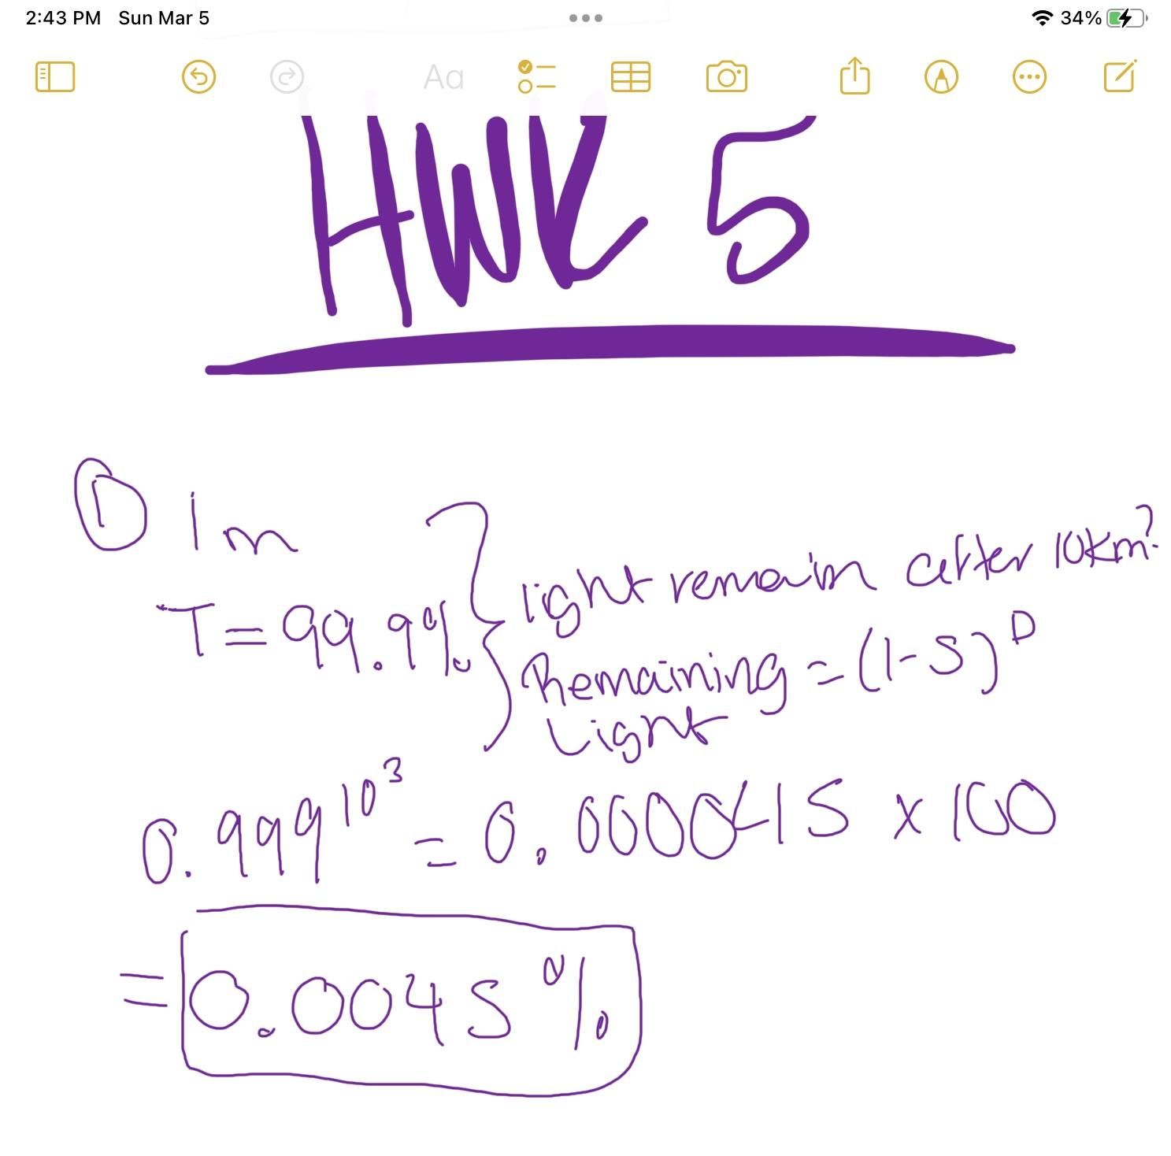

2. A fiber has attenuation of 0.00435 dB/m. What is the total attenuation of a
10-km length?
a. 0.0435 dB
b. 1.01 dB
c. 4.35 dB
d. 43.5 dB
e. We cannot tell without knowing the wavelength.
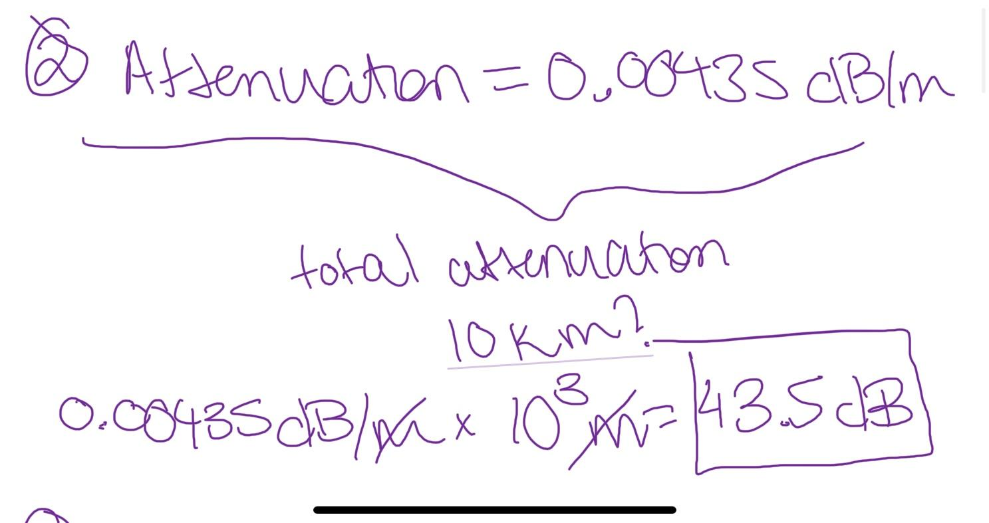

3. If 10 mW of light enters the 10-km fiber in Problem 2, how much light
remains at the output end?
a. 0.00045 mW
b. —33.5 dBm
c. —3.5 dBp,
d. all of the above
e. none of the above
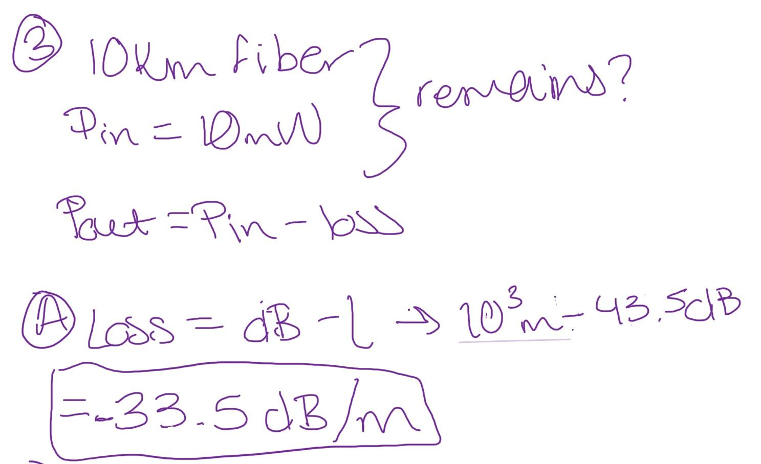

4. You lose 1.0 dB coupling a 1-mW light source into an optical fiber. You need a
signal of 0.1 mW at the other end. How far can you send a signal through fiber
with attenuation of 0.5 dB/km?
a. 1.8 km
b. 10 km
c. 18 km
d. 20 km
e. 40 km
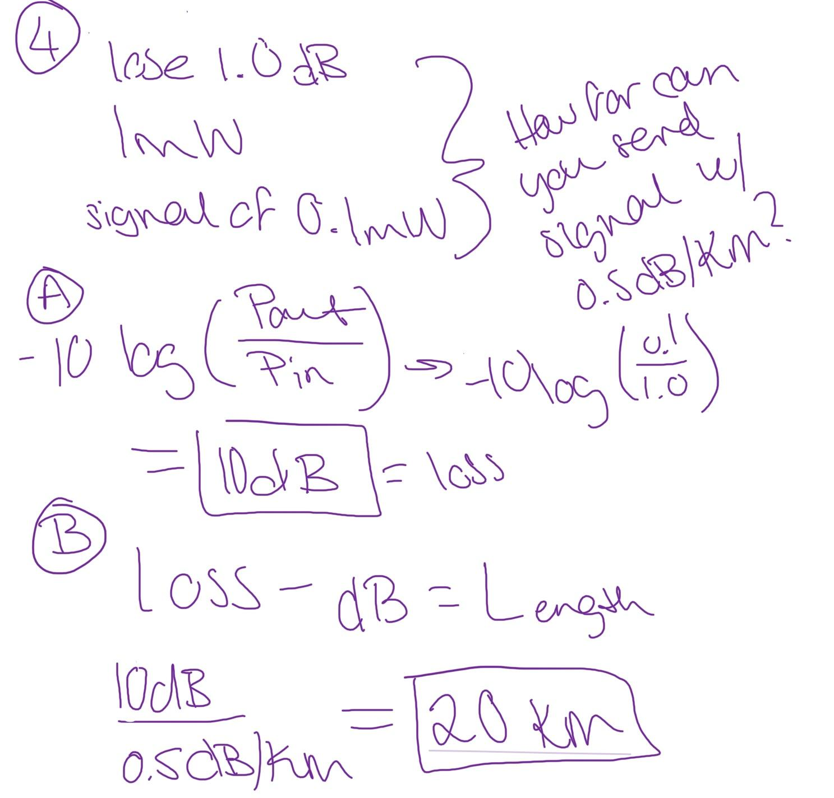

5. You transmit an instantaneous pulse through a 20-km multimode fiber with
total dispersion of 10 ns/km at the signal wavelength. What will the pulse length
be at the end?
a. 200 ns
b. 100 ns
c. 50 ns
d. 20 ns
e. 10 ns
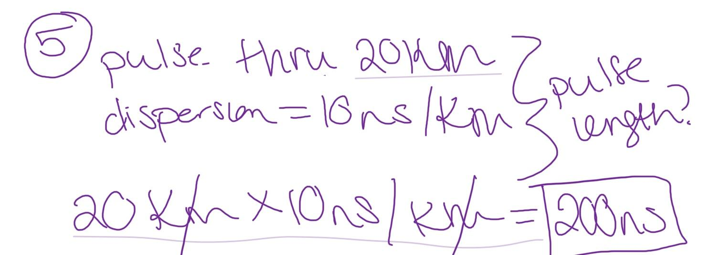

6. You transmit a 100-ns pulse through the same fiber used in Problem 5. What
will the pulse length be at the end?
a. 300 ns
b. 224 ns
c. 200 ns
d. 150 ns
e. 100 ns
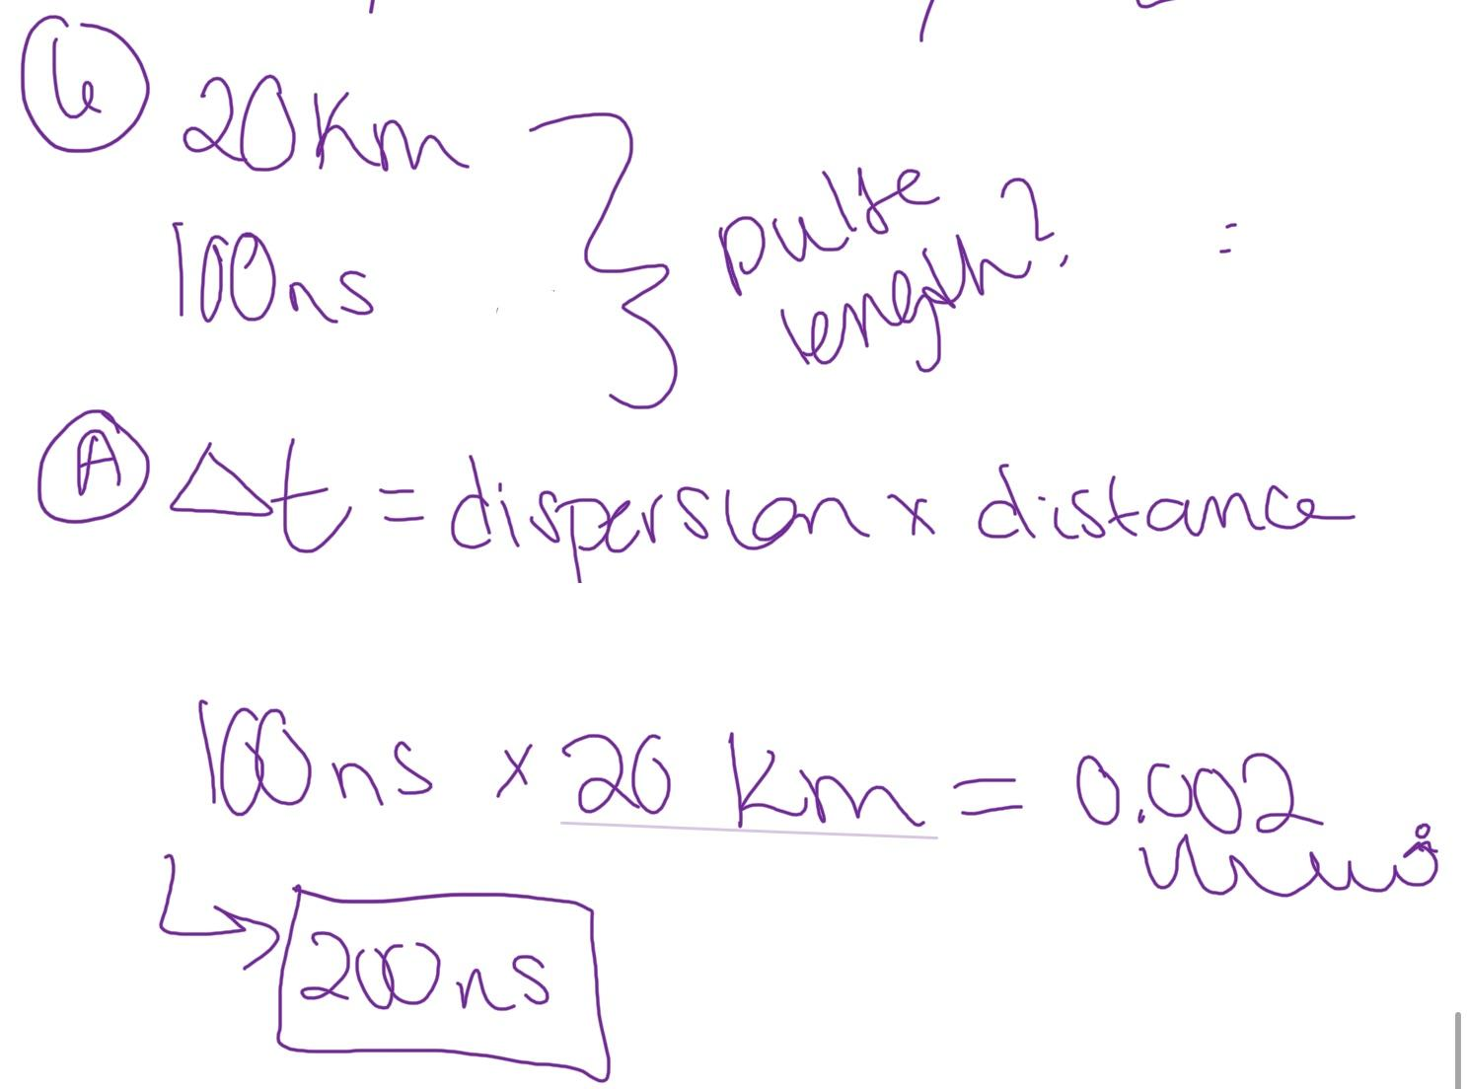

7. You transmit an instantaneous pulse through a 20-km single-mode fiber with
chromatic dispersion of 10 ps/nm-km at the signal wavelength. The spectral width
of the input pulse is 2 nm. What is the pulse length at the end of the fiber?
a. 400 ps
b. 250 ps
c. 200 ps
d. 100 ps
e. 32 ps
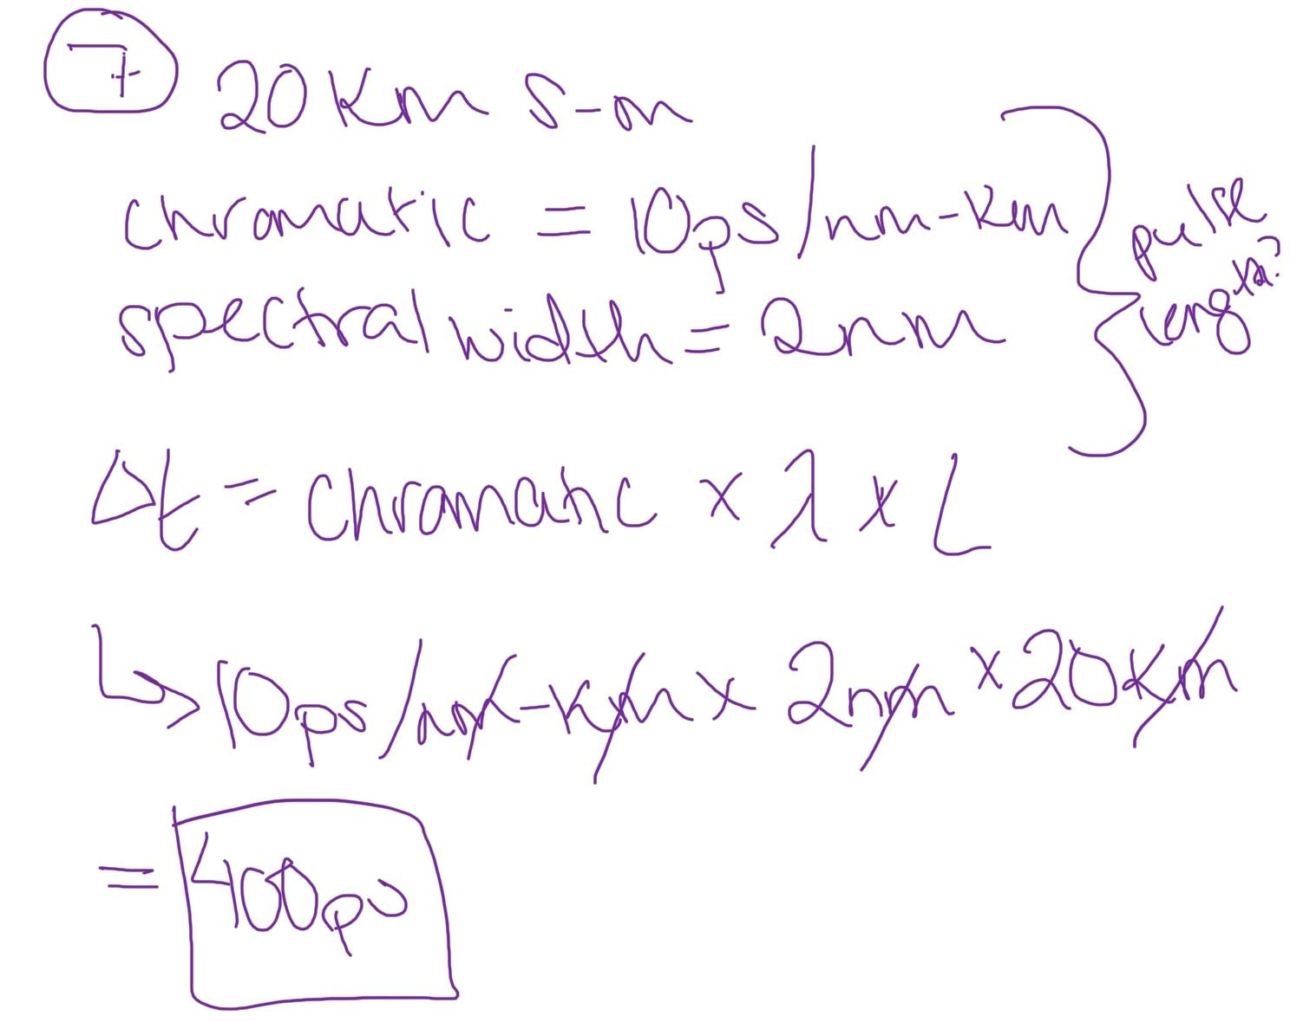

8. You transmit an instantaneous pulse through a 20-km single-mode fiber with
chromatic dispersion of 10 ps/nm-km at the signal wavelength. This time you’ve
spent an extra $2000 for a super-duper laser with spectral width of only
0.002 nm. What is the pulse length at the end of the fiber?
a. 30 ps
b. 20 ps
c. 4 ps
d. 1 ps
e. 0.4 ps
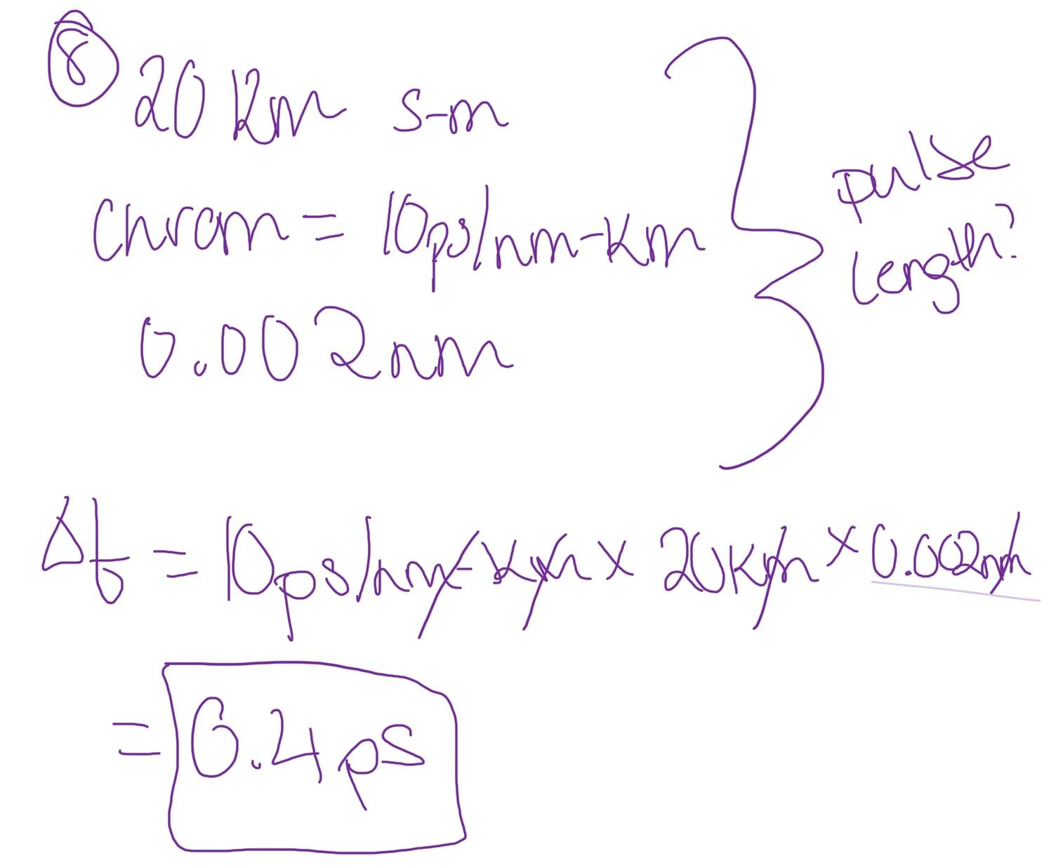

9. A single-mode fiber has material dispersion of 20 ps/nm-km and waveguide
dispersion of —15 ps/nm-km at the signal wavelength. What is the total
chromatic dispersion?
a. 35 ps/nm-km
b. 25 ps/nm-km
c. 5 ps/nm-km
d. 0 ps/nm-km
e. —35 ps/nm-km
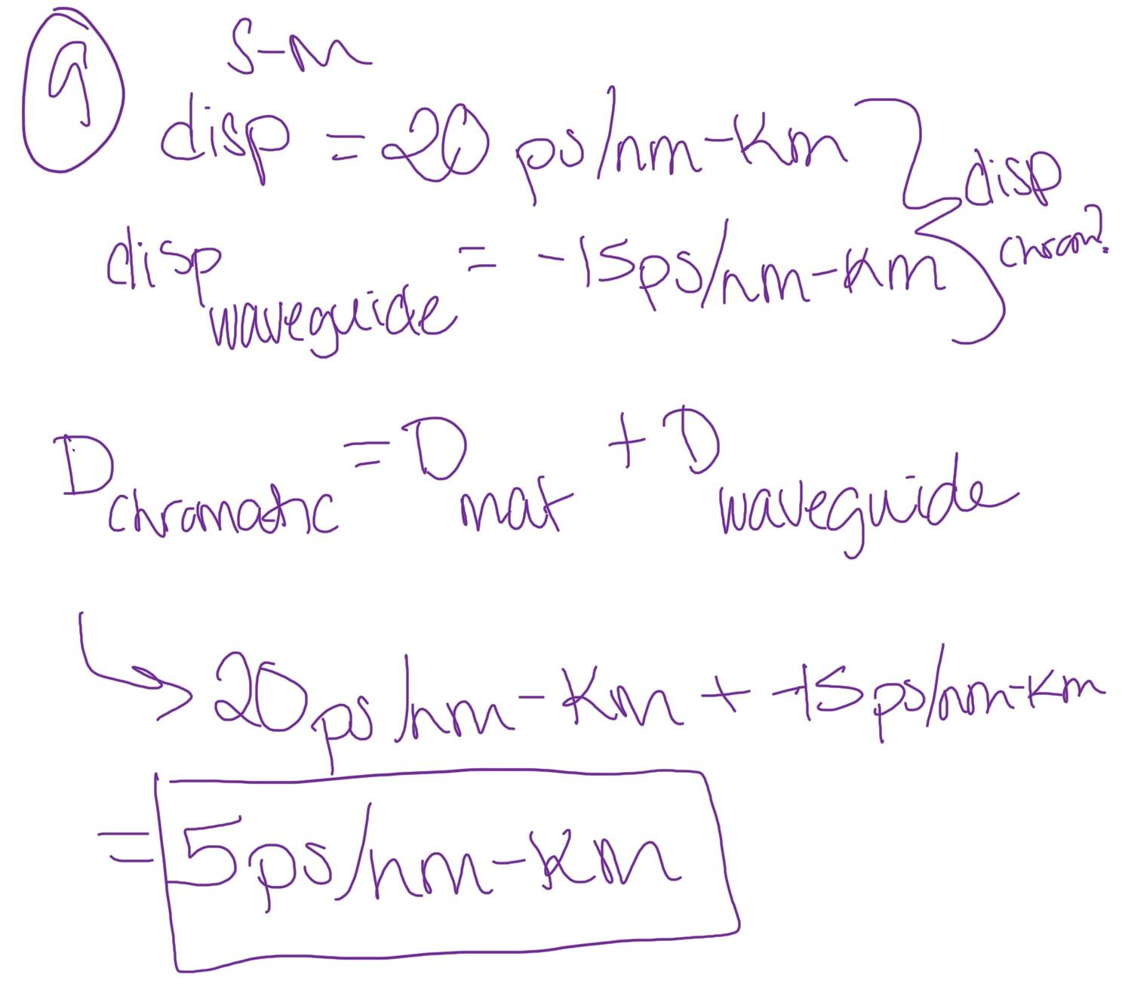

10. You send 200-ps pulses through a 100-km length of the fiber in Problem 9, using
a laser with spectral width of 0.002 nm. What is the width of the output pulse?
a. 1 ps
b. 200 ps
c. 250 ps
d. 400 ps
e. 500 ps
